Digital Streaming

Definition:
# Source: AI Source: Provided by: [Data Path: Persons Table -> ID Column: 1, Name_En Column: Motasem Essam] -> From: [ChatGPT] on [10/26/2025]
Digital Streaming is a modern method of playing music or videos directly online in real time — without downloading the file.
It allows users to instantly access songs, albums, or performances through the internet on platforms such as Spotify or YouTube.

🎶 Key Features:
# Source: AI Source: Provided by: [Data Path: Persons Table -> ID Column: 1, Name_En Column: Motasem Essam] -> From: [ChatGPT] on [10/26/2025]
- Delivers audio or video content over the internet.
- Users can listen or watch instantly without saving the file.
- Available on phones, computers, smart TVs, and tablets.
- Includes both music streaming platforms (audio-focused) and video streaming platforms (visual + audio).
- Offers on-demand access — play anything, anytime, anywhere.

🎵 Examples:
# Source: AI Source: Provided by: [Data Path: Persons Table -> ID Column: 1, Name_En Column: Motasem Essam] -> From: [ChatGPT] on [10/26/2025]
- Spotify – for streaming songs and podcasts (audio).
- YouTube – for streaming music videos and performances (video).
- Apple Music, Amazon Music, TikTok, etc.

🧭 In Short:
# Source: AI Source: Provided by: [Data Path: Persons Table -> ID Column: 1, Name_En Column: Motasem Essam] -> From: [ChatGPT] on [10/26/2025]
Digital Streaming = Listening to or watching music and videos directly online, through platforms like Spotify or YouTube, without downloading — offering instant, on-demand access to media content.

Differences Between Digital Streaming, Audio Streaming Platforms, and Online Video Platforms
# Source: AI Source: Provided by: [Data Path: Persons Table -> ID Column: 1, Name_En Column: Motasem Essam] -> From: [ChatGPT] on [10/26/2025]
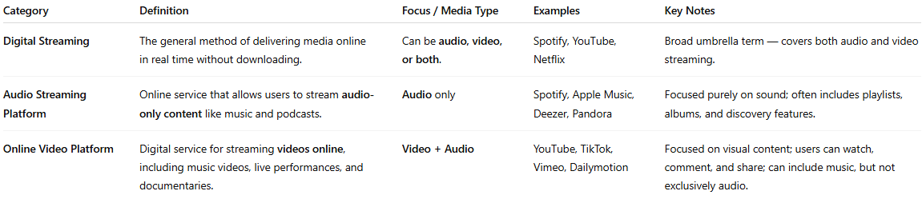
Category | Definition | Focus / Media Type | Examples | Key Notes
Digital Streaming | The general method of delivering media online in real time without downloading. | Can be audio, video, or both. | Spotify, YouTube, Netflix | Broad umbrella term — covers both audio and video streaming.
Audio Streaming Platform | Online service that allows users to stream audio-only content like music and podcasts. | Audio only | Spotify, Apple Music, Deezer, Pandora | Focused purely on sound; often includes playlists, albums, and discovery features.
Online Video Platform | Digital service for streaming videos online, including music videos, live performances, and documentaries. | Video + Audio | YouTube, TikTok, Vimeo, Dailymotion | Focused on visual content; users can watch, comment, and share; can include music, but not exclusively audio.

🧭 In Short:
- Digital Streaming = Broad term for streaming any media online (audio or video).
- Audio Streaming Platform = Subset of digital streaming focused on audio content only.
- Online Video Platform = Subset of digital streaming focused on video content, which may include music.
💡 Tip: Think of it like layers:
Digital Streaming (big umbrella) → Audio Streaming Platforms (audio) + Online Video Platforms (video)

